ADEP V5 ERRORS - "OFFER" MODULE

I. INTRODUCTION
2. REFERENCE DOCUMENTS
This document lists all the errors generated by ADEP V5. For a more general introduction to ADEP before moving on to this module, we recommend that you read the document:
dsiapec-ADEP V5 - Technical specifications

3. PRESENTATION OF THE DOCUMENT
The ADEP application is likely to generate several error messages if one or more management rules have not been respected or if one or more fields have not been filled in.
This document should help ADEP clients to interface their own information systems by correctly intercepting the error messages received. This document lists possible errors and provides the reason(s) for the error and the solutions to be applied.
4. GLOSSARY
Web Services | Web Services 2.0  http://www.w3.org/TR/wsdl20/
WSDL | Web Services Description Language. Describes a public interface for accessing one or more Web Services. This is an XML-based description that indicates "how to communicate to use the service"; the communication protocol and message format required to communicate with this service. The possible operations and messages are described in an abstract way, but this description refers to concrete network protocols and message formats.
SOAP | Simple Object Access Protocol. Object-oriented RPC protocol based on XML. It allows messages to be transmitted between remote objects, which means that it allows an object to invoke the methods of objects physically located on another machine.  SOAP 1.2  Simple Object Access Protocol. Object-oriented RPC protocol based on XML. It allows messages to be transmitted between remote objects, which means that it allows an object to invoke the methods of objects physically located on another machine.  SOAP 1.2  http://www.w3.org/2000/xp/Group/
HR-XML | HR-XML is an independent, not-for-profit consortium which aims to promote e-commerce and the exchange of data relating to human resources management at a global level, in particular through the promotion of standard XML vocabulary in human resources management. HR-XML has produced 2 recruitment standards: SEP and SIDES.
SEP | SEP  []
SIDES | SIDES 1.1  []
CPO | Cross Process Objects: designates the HR-XML modules shared between the two standards SEP and SIDES.  []
MD5 | MD5 (Message Digest 5) is a cryptographic hash function used to obtain a digital fingerprint (in this case a sequence of 128 bits or 32 characters in hexadecimal notation) for each message, with a very high probability that the fingerprints of two different messages will be different.  []

II. ERROR MANAGEMENT PRINCIPLE
As specified in the Web Services/SOAP architecture, the management of errors on a service call is implemented by a "service fault" mechanism.
• If no errors are returned when a Web Service is called, this means that the service called has not generated any blocking errors during processing. The service then returns the output parameters defined in the WSDL for this service.
In the case of an update to the data present in the Apec IS (e.g. creation of an offer or modification of the status of an offer), the processing may encounter errors of varying severity but which do not affect the processing; in this case, the Web Service returns a ApplicationAcknowledgementType object. This type is described in detail in Chapter 1 below.
• If a fault is returned, it means that there has been a blocking error and it is therefore up to the calling application (client HRIS) to manage this fault and obtain the corresponding error message.
In Java, the fault and error message are obtained using a "catch Exception". Example:
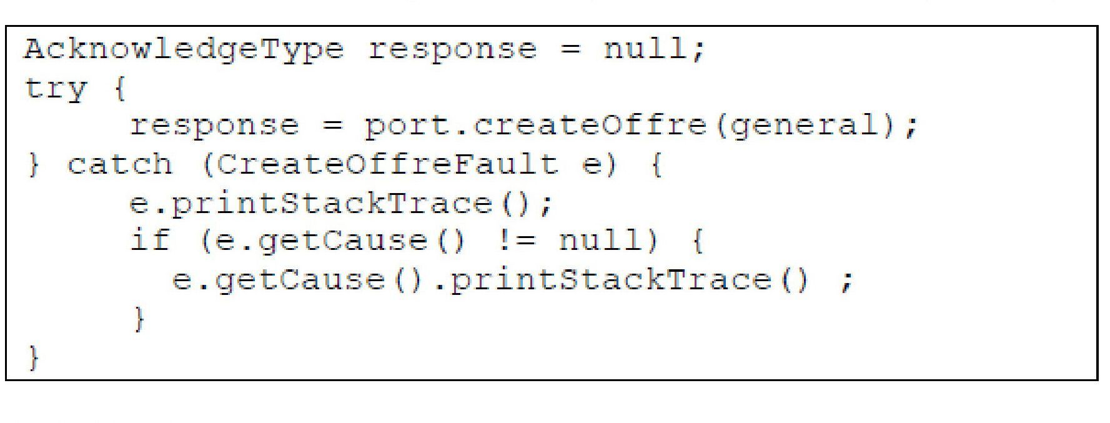

1. THE AcknowledgementType TYPE
In response, many ADEP Web Services return a transaction acknowledgement indicating any errors encountered when processing the client request. The acknowledgement is returned in the form of an AcknowledgeType element. This type is derived from the HR-XML CPO standard, and can be viewed in detail at this address:
[]
This object describes the result of processing on the entities involved in the transaction and any errors on these entities. These errors can be a warning about a field that has not been filled in, or an error that is fatal to the processing of the entity, such as a mandatory field that has not been supplied.

1.1 THE ApplicationAcknowledgementType TYPE
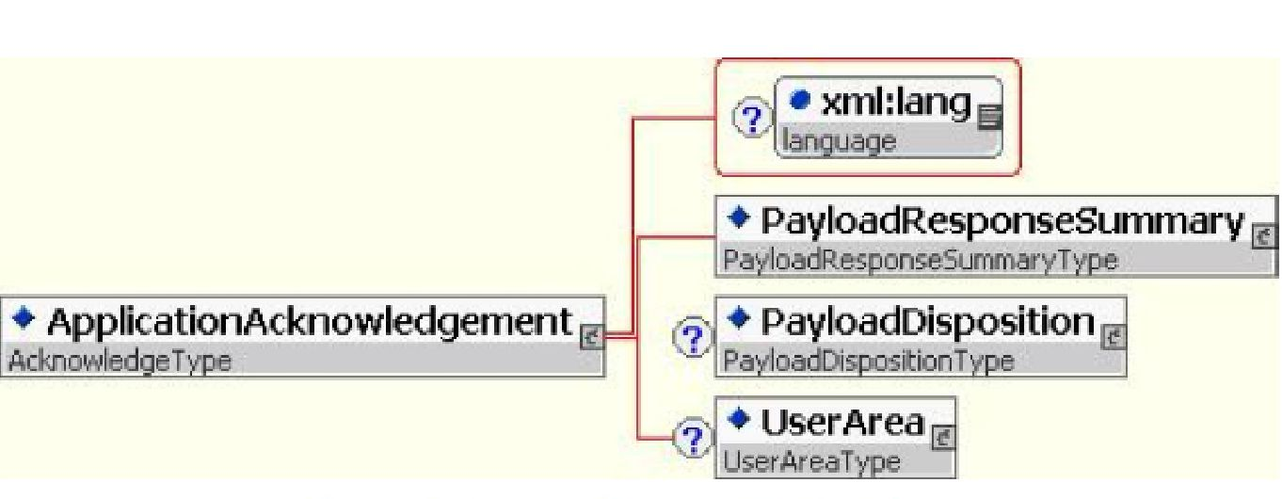
Figure 1: The AcknowledgeType type
Element | Description | ADEP processing | Format
xml :lang | Language of the offer | Ignored
PayloadResponseSummary | Summary of client message processing | Supplied | see 1.2 below
PayloadDisposition | Client message processing details | Supplied | see 1.3 below
UserArea |  | Ignored

1.2 The PayloadResponseSummary ELEMENT
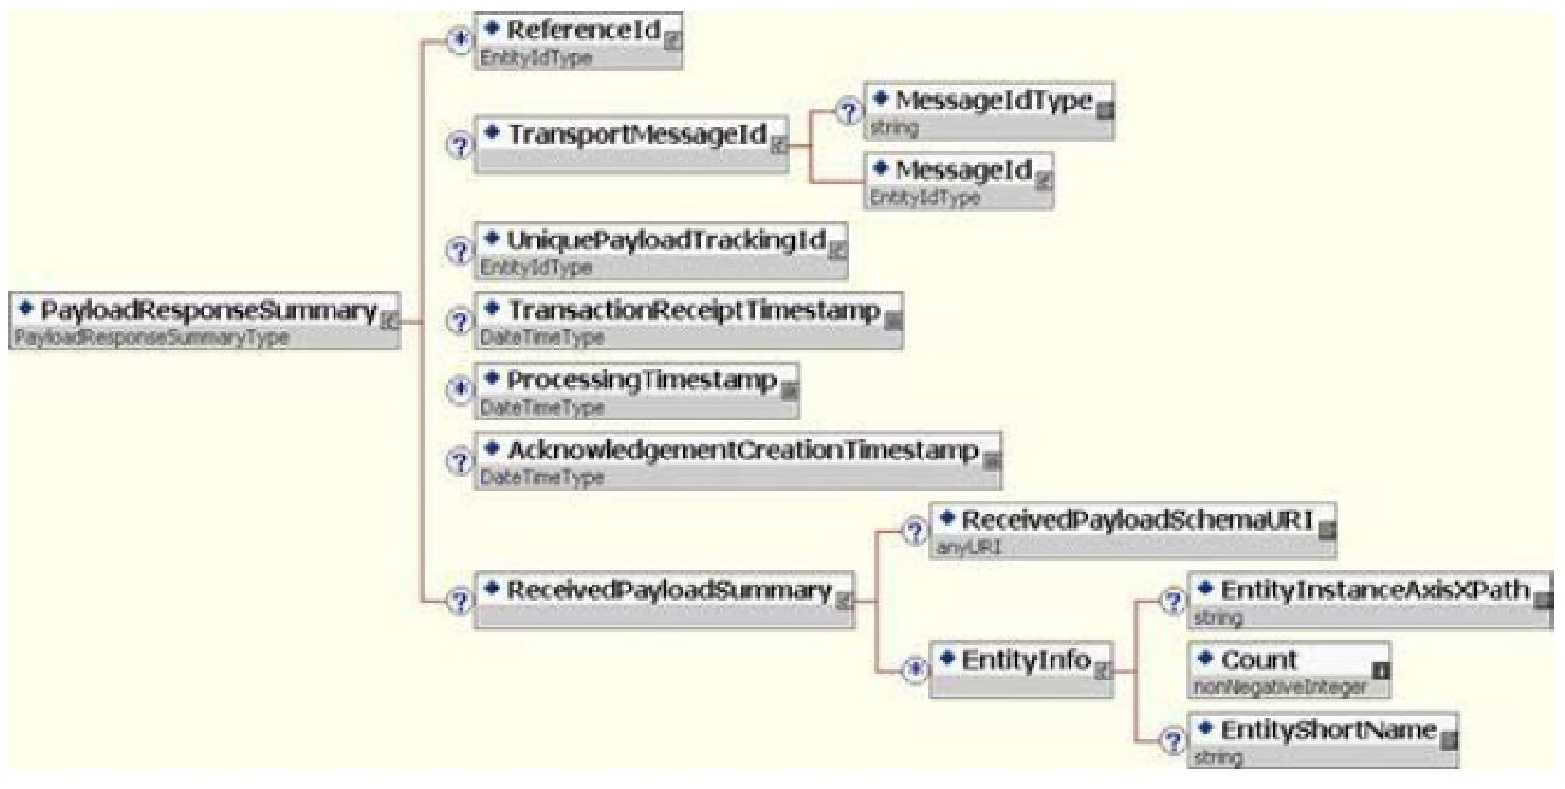
Figure 2: The PayloadResponseSummaryType type
Element | Description | ADEP processing
ReferenceId |  | Ignored
TransportMessageId |  | Ignored
UniquePayloadTrackingld | Transaction identifier supplied by the client (see Technical specifications - ADEP document  V2.pdf) | Supplied
TransactionReceipt-Timestamp | Client request reception timestamp | Supplied
ProcessingTimestamp |  | Ignored
AckowledgementCreation- | Acknowledgement creation timestamp | Supplied
Timestamp
ReceivedPayloadSummary | Summary of client request processing | Supplied
ReceivedPayloadSchemaURI |  | Ignored
EntityInfo | Information on entities processed | Supplied (one per type of entity)
EntityInstanceAxisXPath | Simplified Xpath expression identifying the element of the XML flow corresponding to the entity being processed | Supplied
Count | Number of entities of the same type | Supplied
EntityShortName | Short name of the entity processed | Supplied
1.3 The PayloadDisposition ELEMENT
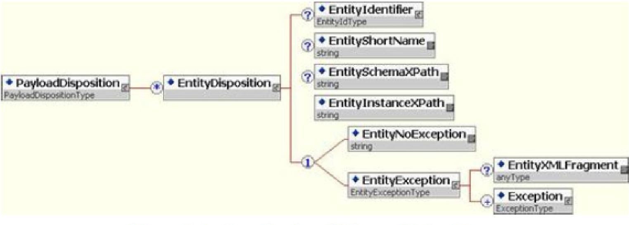
Figure 3: The PayloadDispositionType type
An "entity" corresponds to an ADEP business object, such as an offer, an application, a company, a skill level, a place of work, a desired salary, and so on.
 | For each entity, the processing report is returned.
 | Element | Description | ADEP processing | Format
 | EntityDisposition | Result of entity processing | Supplied
 | EntityIdentifier | Identifier of the entity processed | Supplied | This is any character string used to identify the entity.
 | EntityShortName | Short name of the entity processed | Supplied
 | EntitySchemaXPath |  | Ignored
 | EntityInstanceXPath | Simplified Xpath expression identifying the element of the XML flow corresponding to the entity being processed | Supplied
 | EntityNoException | Certifies that the processing of the entity has been successfully completed | Supplied if successful | "true”
 | EntityException | Certifies that the processing of the entity has been completed with errors | Supplied if unsuccessful | see 1.4 below
1.4 THE EntityExceptionType TYPE
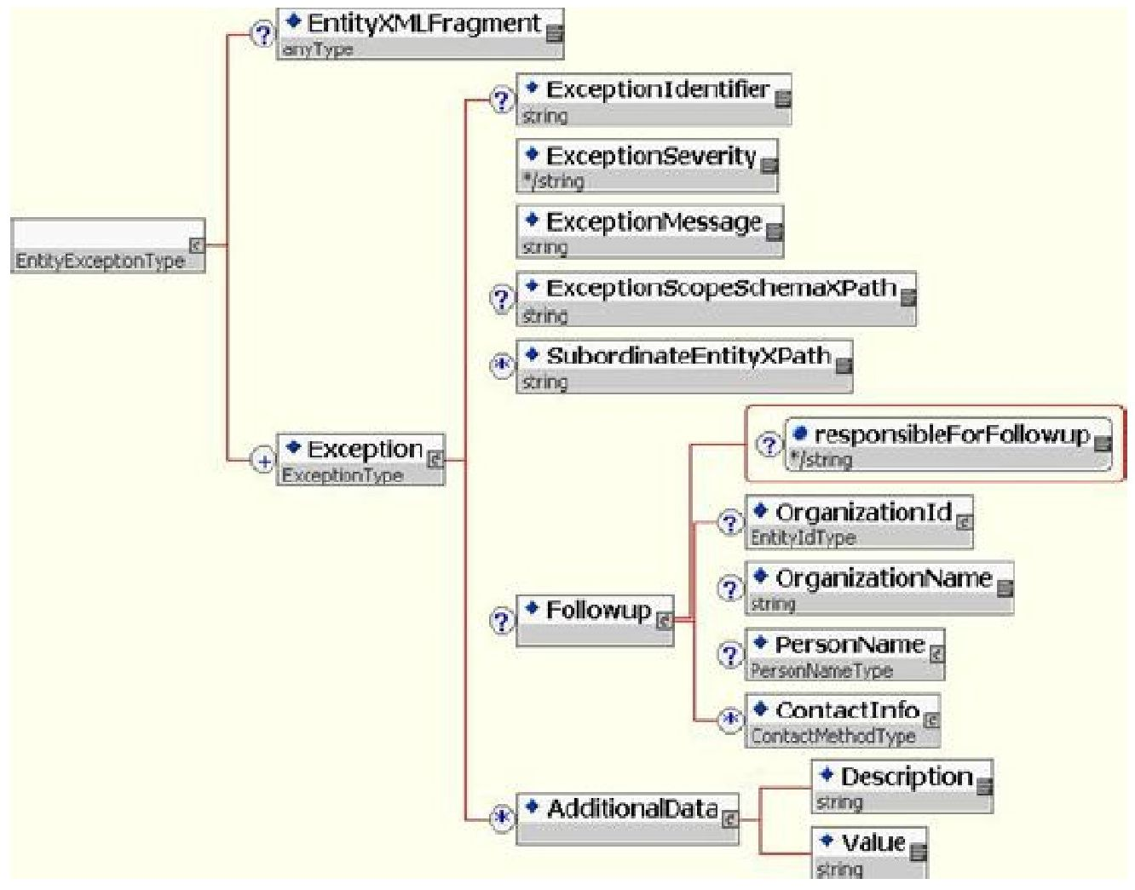
Figure 4: The EntityExceptionType type
Element | Description | ADEP processing | Format
EntityXMLFragment |  | Ignored
Exception | Errors encountered | Supplied
ExceptionIdentifier | Error number | Supplied | Whole, see Ill below
ExceptionSeverity | Severity of error | Supplied | “warning”, “Error” or “Fatal”
ExceptionMessage | Error wording | Supplied | Character string see Ill below
ExceptionScopeSchemaXPath |  | Ignored
SubordinateEntityXPath |  | Ignored
Followup |  | Ignored
AdditionalData |  | Ignored

III. ADEP ERRORS

1. COMMON SEP/SIDES ERRORS
No. | Description | Explanations | Solutions
002 | API_002_UNABLE_TO_UNMARSHALL _ERROR | Error reading XML flow (internal error). | Contact ADEP technical support.
023 | API_023_VALIDATION_XML_ERROR | The XML flow sent has not been validated by the XML diagram. | Modify the XML flow sent from the calling program, taking account of the XSD files.
100 | API_100_UNABLE_TO_CREATE_ERROR | Local context initialisation error (internal error). | Contact ADEP technical support.
102 | API_102_ATS_PASSWORD_INVALID_ERROR | The key supplied is invalid. | An authentication password needs to be regenerated.

103 | API_103_USER_NOT_FOUND_ERROR | The recruiter does not exist (MD5 key mode). | From the back office, you need to create a user or check that the authentication is for a correct user/partner/password.
105 | API_105_ID_TRANS_INVALID_ERROR | Validation of the session identifier has failed (information is validated at this level) | Enter a transaction identifier up to 100 characters long.
106 | API_106_QUESTION_NOT_FOUND _ERROR | No means of authentication (MD5 key mode or idTrans) is specified. | N/A
108 | API_108_ID_TRANS_NOT_UNIQUE _ERROR | The transaction identifier is already in use. | A different transaction identifier is required.
303 | API_303_NO_CANDIDATURE_ERROR | You must fill in the application: either url or email | N/A
304 | API_304_URL_FORMAT_ERROR | The format of the application URL is invalid. | Make the application URL compliant.  Must comply with REGEXP  URL_CANDIDATURE described below in the document.
308 | API_308_INVALID_EMA_FORMAT _ERROR | The email format is invalid or the email is missing. | Make the email compliant.
309 | API_309_INVALID_FORMAT_REF _ERROR | The offer reference is invalid or not supplied. | Correct the format of the offer reference in the XML flow (must be less than 20 characters).
310 | API_310_INVALID_SIRET_ERROR | The company's SIRET number is invalid or not supplied. | Correct the format of the company's SIRET number in the XML flow.
311 | API_311_INVALID_NAF_ERROR | The NAF code is invalid or not supplied. | Correct the format of the NAF code in the XML flow.
312 | API_312_CLIENT_NOT_FOUND _ERROR | The company assigned to the offer is not found in the Apec database. | Contact ADEP technical support.
313 | API_313_INVALID_CIV_ERROR | The civil status code is not one of the expected values. | Check the authorised values for the CIVILITE_DOMAIN domain in the ADEP documentation.
315 | API_315_INVALID_CODE_JOB _ERROR | The position stipulated in the offer is not valid. | Check the value of the code entered.
316 | API_316_INVALID_INL_ERROR | The position title is not valid. | Check the length of the position “title” field. It is limited to 76 characters without the word M/F and 80 characters with the word M/F.
317 | API_317_INVALID_SAL_MIN_ERROR | The minimum salary is not valid. | You need to check the "minimum salary" field in your XML code.
318 | API_318_INVALID_SAL_MAX_ERROR | The maximum salary is not valid. | You need to check the "maximum salary" field in your XML code.
319 | API_319_INVALID_EXP_ERROR | The level of experience is not valid. | Check the authorised values for the domain NIVEAU_EXPERIENCE_DOMAIN in the ADEP documentation.
320 | API_320_INVALID_CON_ERROR | The contract type is not valid. | Check that your company has the right to offer the type of contract specified (depending on the company, a recruiter may be refused certain types of contract). Check that you have entered an acceptable value for the XML format used.
321 | API_321_INVALID_NB_POS_ERROR | The number of positions indicated is not valid. | Check that the number of positions is between 1 and 10.
322 | API_322_INVALID_TYPE_ERROR | The offer type is not valid. | You need to check that there is a single "offer type" field in your XML code.

323 | API_323_INVALID_LIEU_ERROR | No location has been specified in the offer, or the location(s) specified are not valid. | You need to specify a location in your XML code. Check the locations provided.
324 | API_324_NB_LIEU_ERROR | The number of locations is greater than the number of positions indicated. | Check that the total number of locations (in the case of a region, including the locations included in this region code) does not exceed the number of positions indicated.
326 | API_326_MORE_THAN_ONE_REGION _ERROR | Rule on regions not respected. | If your flow contains a region, it must not contain any other location.
327 | API_327_ODD_ODA_ADR_ERROR | The free text position address field is empty. | N/A
329 | API_329_CLIENT_DIRECT_ACCESS _ERROR | Access refused in “direct client” mode. | Check the conditions of use for “direct client” mode.
330 | API_330_CLIENT_INDIRECT_ACCESS _ERROR | Access denied in “indirect client” mode. | Only certain organizations can access ADEP in "indirect client" mode (recruitment agencies, temporary employment agencies, etc.). Check that your organization is authorised to access ADEP in "indirect client" mode, otherwise use "direct client" mode.
331 | API_331_TOO_LONG_OFFRE_ERROR | The body of the offer is too long. | You need to reduce the text of the offer in your XML code. Must be less than 3,000 characters.
332 | API_332_EMPTY_BODY_ERROR | The body of the offer is void. | Fill in the body of the offer.
333 | API_333_INVALID_SAL_TEX_ERROR | The text salary is not supplied or is empty or too long. | Check the RatesType description tag in your flow.
335 | API_335_INVALID_PRF_INN_ERROR | The international profile indicator is not valid. | Review the indicator specifications.
336 | API_336_INVALID_LIEU_SIZE | The size of the location text is too large. | Reduce the number of characters in the location text. Must be less than 18 characters long.
337 | API_337_TOO_SHORT_OFFRE_ERROR | The body of the offer is too short. | You need to increase the offer text in your XML code. Must be longer than 200 characters.
338 | API_338_INVALID_HTML_TAG_ERROR | The body of the offer contains invalid tags. | Check the body text of the offer in your XML code.
340 | API_340_STATE_ERROR | The status indicated is not valid. | You have probably tried to change the status of an offer to an unknown status.
350 | API_350_NO_STATE_ERROR | The status has not been specified. | You have probably tried to change the status of an offer without specifying the new status.
351 | API_351_INVALID_STATE_ERROR | The specified status is unknown. | You have probably tried to change the status of an offer to an unrecognised status. Check that the value is included in the domain STATUT_OFFRE_DOMAIN.
352 | API_352_CHANGEMENT_ETAT_ERROR | The change of status requested is not authorised. | You have probably tried to change the status of an offer to a new, unauthorised status. You can refer to the document Offer Module to check the stages in the life cycle of an offer and the associated status changes.
353 | API_353_OFFRE_A_ETAT_DEMANDE | The offer is already in requested status, so no change of status is made. | You have tried to change the status of an offer to the same status.
354 | API_354_INVALID_TYPE_LIEU_ERROR | Type of location invalid or not specified | Area.type must be specified. For example, INSEE or APEC.
355 | API_355_INVALID_ZONE_LIEU_ERROR | Invalid or missing field | Specify a movement area (from the predefined values) in Area.Value.
356 | API_356_INVALID_CODE_LIEU_ERROR | Invalid or unauthorised common code. | Paris (75056), Lyon (69123), Marseille (13055) are prohibited.

361 | API_361_INVALID_PUBLICATION_DELAYS | Your offer was published more than 30 days ago. It cannot be republished. | N/A
362 | API_362_INVALID_PUBLICATION_POSITION | Offers for public sector management positions cannot be republished. | N/A
363 | API_363_INVALID_TYPE_POSTE | The item type is invalid. | Fill in this field.
364 | API_364_INVALID_SUISSE_INL_ERROR | The publication of offers in Switzerland is prohibited. | N/A
365 | API_365_INVALID_SUISSE_LIEU_ERROR | The publication of offers in Switzerland is prohibited. | N/A
366 | API_366_EMPTY_LOGO_ERROR | The logo is not filled in. | Fill in this field.
367 | API_367_EMPTY_CONDITION_ERROR | The validation condition is not set. | The validation condition must be filled in.
368 | API_368_INVALID_CONDITION_ERROR | The validation condition is not valid. | The validation condition must be true.
369 | API_369_INVALID_LOGO_ERROR | The information on the logo is invalid. | Comply with the logo management rules.
370 | API_370_INVALID_PRENOM_ERROR | The contact first name of the actual client is not valid. | Comply with the rules for managing first names.
371 | API_371_INVALID_NOM_ERROR | The contact last name of the actual client is invalid. | Comply with the rules for managing last names.
372 | API_372_INVALID_CODE_POSTAL_ERROR | The postcode of the actual client is invalid. | Comply with the rules for managing postcodes.
373 | API_373_INVALID_VILLE_ERROR | The town of the actual client is not valid. | Comply with the rules for managing town name.
374 | API_374_INVALID_ADRESSE_ERROR | One of the address lines for the actual client is invalid. | Comply with the rules for managing address line.
375 | API_375_INVALID_RAISON_SOCIALE _ERROR | The company name of the actual client is invalid. | Comply with the rules for managing company name.
376 | API_376_INVALID_TEL_ERROR | The contact phone number of the actual client is invalid. | Comply with the rules for managing telephone.
378 | API_378_NO_CANDIDATURE_EMAIL _ERROR | No application email address is given. | Enter an application email address.
379 | API_379_TOO_LONG_EMAIL_ERROR | The application email is too long. | The email address must be less than 240 characters long.
382 | API_382_TOO_LONG_PRENOM_ERROR | The first name of the actual client is not valid. | The actual client's first name must be less than 30 characters long.
383 | API_383_TOO_LONG_NOM_ERROR | The last name of the actual client is invalid. | The last name of the actual client must be less than 30 characters long.
387 | API_387_INVALID_ACTIVITE_ERROR | The sector of activity of the actual client is not entered. | Enter this value (NAF code).
388 | API_388_OFFRE_CONFIDENTIELLE _ERROR | Some of the offer's confidentiality settings are invalid. | Comply with the rules for managing confidential offers.
390 | API_390_MORE_THAN_ONE_REF_FOUND _ERROR | The external client identifier has been assigned to several offers. | An offer with this reference is already known to Apec. Contact ADEP technical support to resolve any duplicates.
391 | API_391_REF_NOT_FOUND_ERROR | The client reference for the offer does not exist. | When an offer is modified, the client reference must already be known to Apec. You need to check your offer identifier.

392 | API_392_ID_OFFRE_ERROR | The offer's Apec identifier does not return any offers. | You need to check your Apec identifier. Perhaps you have confused your client reference with the Apec reference.
393 | API_393_INVALID_IDENTIFICATION _ERROR | No offer identifier was provided. | You need to modify your XML flow to specify an offer identifier.
394 | API_394_INVALID_DURATION_ERROR | The duration must be a number between 1 and 99. | You need to modify your XML flow and enter a number between 1 and 99 in the Duration tag.
395 | API_395_SSII_STATUS_JOB_ERROR | The status of the position is incompatible with the company's type of agreement. | You need to modify your XML flow and check the status of the position in the StatusJob tag: IT services companies cannot create 'public sector executive' jobs.
396 | API_396_INVALID_STATUS_JOB_ERROR | The job status is incorrectly formatted. | You need to modify your XML feed and indicate a job status in the StatusJob tag from one of the following values [CADRE_PRIVE, CADRE_PUBLIC,AGENT_DE_MAITRISE].
397 | API_397_INVALID_CON_AND_DURATION _ERROR | The duration of the contract is incompatible with the type of contract. | You need to modify your XML flow and check the duration of the contract in the Duration tag and the type of contract. An open-ended contract cannot have a contract term.
398 | API_398_UPDATE_POSITION _NOT_AVAILABLE | Offer modifications are no longer possible via ADEP. | Contact technical support.
399 | API_399_UNABLE_TO_PUBLISH_OFFRE | The offer has been created, but an internal error prevents it from being published. | This error will be dealt with by an APEC consultant.
400 | API_400_INVALID_PART_TIME_DURATION _ERROR | UserArea.PartTimeDuration tag | > if the offer is part-time, then the duration is mandatory.  > the duration of part-time work is defined in the value domain  TEMPS_PARTIEL_DUREE_DOMAIN
401 | An error has occurred | > Contact APEC | > Contact APEC
402 | API_402_INVALID_DATE_POSITION _TAKEN_ERROR | userArea.DatePositionTaken tag | > date of taking up position  > greater than or equal to today's date
403 | API_403_INVALID_RELEASE_DATE _ERROR | userArea.ReleaseDate tag | > date of publication of the offer  > greater than or equal to today's date  > less than or equal to today's date + 60 days  > less than the date of taking up the position
404 | API_404_INVALID_INTERLOCUTEUR_SUIVI _ERROR | SEP tag  > howToApply.PersonName:  > .Affix type='formOfAdress'  > .GivenName  > .FamilyName  > .Affix type='qualification'  SIDES tag  > positionContact.ContactInfo:  > .Affix type="formOfAdress"  > .GivenName  > .FamilyName  > .Affix type="qualification" | > optional  > if completed, then civil status/given name/family name/job title are mandatory  > the civil status is defined in the CIVILITE_DOMAIN value domain  > job title: maximum 80 characters  > given name: maximum 30 characters and must verify the regular expression:  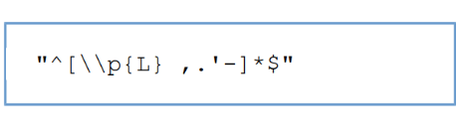  > family name: maximum 30 characters and must verify the regular expression:  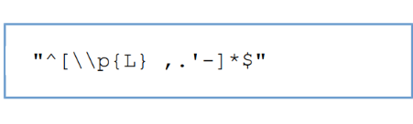
405 | API_405_INVALID_TEMPS_PARTIEL _ERROR | userArea.PartTime tag | > the part-time indicator is mandatory

406 | API_406_INVALID_ORGANIZATION_NAME _ERROR | SEP tag:  > FormattedDescription name= "ORGANIZATION_NAME"  SIDES tag:  > userArea.OrganizationName | > mandatory  > maximum 255 characters
407 | API_407_INVALID_ORGANIZATION _DESCRIPTION_ERROR | SEP tag:  > FormattedDescription name= "ORGANIZATION_DESCRIPTION"  SIDES tag:  >  userArea.OrganizationDescription | > mandatory  > minimum 100 characters  > maximum 3000 characters
408 | API_408_INVALID_PROFILE _DESCRIPTION_ERROR | SEP tag:  > FormattedDescription name= "PROFILE_DESCRIPTION"  SIDES tag:  > userArea.ProfileDescription | > mandatory  > minimum 100 characters  > maximum 3000 characters
409 | API_409_INVALID_PRESENTATION _DESCRIPTION_ERROR | SEP tag:  > FormattedDescription name= "PRESENTATION_DESCRIPTION"  SIDES tag:  >  userArea.PresentationDescription | > optional  > if completed: maximum 500 characters
410 | API_410_INVALID_RECRUITMENT _DESCRIPTION_ERROR | SEP tag:  > FormattedDescription name= "RECRUITMENT_DESCRIPTION"  SIDES tag:  > userArea.RecruitmentDescription | > optional  > if completed: maximum 500 characters
411 | API_411_INVALID_URL_VIDEO_ERROR | userArea.UrlVideo tag | > optional  > URL youtube/vimeo/dailymotion video  > see REGEXP URL_VIDEO described below.
412 | API_412_INVALID_DISPLAYED_PAY_ERROR | userArea.DisplayedPay tag | > the salary display method is mandatory.  > see value domain  SALAIRE_TEXTE_DOMAIN
413 | API_413_WRONG_COMPETENCY_ EVIDENCE_ERROR | The level of experience is not given. | Check the authorised values for the domain NIVEAU_EXPERIENCE_DOMAIN in the ADEP documentation.
417 | API_417_INVALID_STAGE_DISPLAYED_PAY_ERROR | ssuserArea.DisplayedPay tag | - The salary display method is mandatory  > see value domain  SALAIRE_TEXTE_DOMAIN
418 | ERECRUT_STAGE_418_EDUCATION_LEVEL_ERROR | Education.educationLevel tag | > The level of education is mandatory for an internship offer.  > see value domain  NIVEAU_ETUDE_DOMAIN
> REGEXP URL_CANDIDATURE

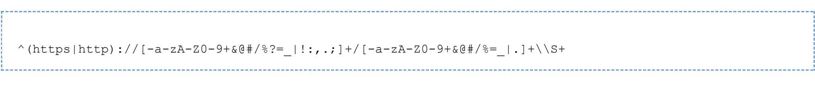
> REGEXP URL_VIDEO for youtube/vimeo

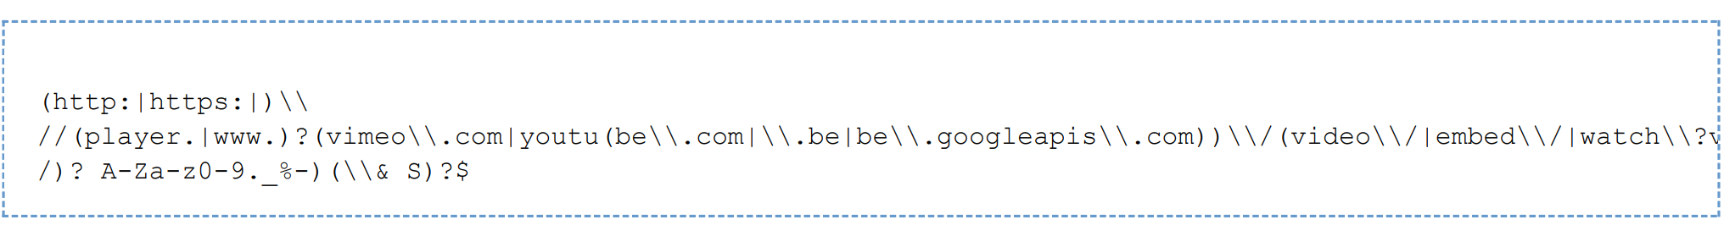
> REGEXP URL_VIDEO for Dailymotion

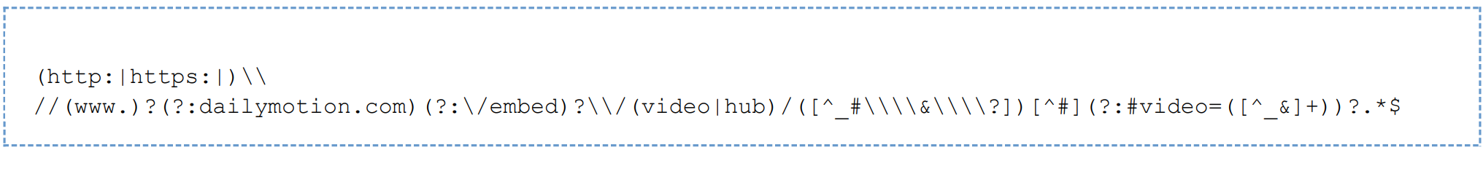

2. SEP ERRORS
No. | Description | Explanations | Solutions
1336 | API_1336_URL_NOT_ALLOWED_ODC_ERROR | An application URL has been supplied but is prohibited for a confidential offer (ODC). | Only ODD-type offers can have an application URL.
1370 | API_1370_INTERLOCUTEUR_ABONNE_ NOT_FOUND_ERROR | The recruiter linked to the offer has not been found in the Apec database. | From the back office, you need to create a user or check that the authentication is for a correct user/partner/password.
1371 | API_1371_ENTREPRISE_INTERLOCUTEUR _NOT_FOUND_ERROR | The company linked to the contact was not found in the Apec database. | Contact ADEP technical support.
1372 | API_1372_ENTREPRISE_DIRECTE_NOT _FOUND_ERROR | The company advertising the offer has not been found in the Apec database. | Contact ADEP technical support.
1373 | API_1373_MORE_THAN_ONE _ENTREPRISE_ERROR | Several companies match the data provided in the Apec database. | Contact ADEP technical support.
1374 | API_1374_LIEUX_NOT_FOUND_ERROR | No place attached to the offer in the Apec database. | N/A
1376 | API_1376_SEP_POSITION_LANGUAGE_ERROR | The language of the offer is incorrect. | Check the language code supplied.
1377 | API_1377_SEP_INVALID_OFFRE_ERROR | The offer validation condition is not valid. | Check that the body text of the offer is correctly completed, and that the offer tag is not present several times.
1378 | API_1378_SEP_INVALID_LOGO_ERROR | The information on the logo is invalid. | Comply with the logo management rules.
1379 | API_1379_SEP_POSITION_BODY_ERROR | No data found for the body of the offer. | Enter this value.
1380 | API_1380_SEP_POSITION_SUPPLIER_ERROR | HR-XML structure error in the Position supplier section. | Be sure to respect entity naming (see ADEP constants). In particular, check that the "relationship" property is correctly filled in.
1381 | API_1381_SEP_POSITION_PROFILE_ERROR | HR-XML structure error in the Position profile section. | Be sure to respect entity naming (see ADEP constants).
1382 | API_1382_SEP_POSITION _ORGANIZATION_ERROR | HR-XML structure error in the Organization section. | Be sure to respect entity naming (see ADEP constants).
1383 | API_1383_SEP_POSITION_DETAILS_ERROR | HR-XML structure error in the Position detail section. | Be sure to respect entity naming (see ADEP constants)
1384 | API_1384_SEP_POSITION_CLASSIFICATION _ERROR | The value in the PositionClassification field is incorrect. | Check the management rules for the type of contract.
1385 | API_1385_SEP_POSITION_GLOBAL _EXPERIENCE_COMPETENCY_ERROR | No data found for the overall experience criterion. | Enter this value.
1386 | API_1386_SEP_POSITION_TYPE_ERROR | HR-XML structure error in the field  FormattedPositionDescription. | A FormattedPositionDescription element indicating the type of offer (ODD, ODC) must be present in the flow.

1388 | API_1388_SEP_POSITION_DISPLAY _LOGO_ERROR | The value in the 'Logo display' field is empty or invalid. | Review the specifications for this indicator.
1389 | API_1389_SEP_POSITION_NUMBER _TO_FILL_ERROR | The number of positions offered is not given. | Provide the number of positions on offer.
1390 | API_1390_SEP_ORGANIZATION _CONTACT_ERROR | HR-XML structure error in the Organization contact section. | Check that the Contact block has been filled in correctly.
1391 | API_1391_SEP_ORGANIZATION_CONTACT _NAME_ERROR | HR-XML structure error in the Organization contact section. | Check that the name of the Contact block is correct.
1392 | API_1392_SEP_ORGANIZATION_CONTACT _METHOD_ERROR | HR-XML structure error in the Organization contact section. | Check that the contact method in the Contact block is correct.
1393 | API_1393_SEP_ORGANIZATION_CONTACT _POSTAL_ERROR | HR-XML structure error in the Organization contact section. | Check that the postal address in the Contact block is correct.
1397 | API_1397_SEP_HOW_TO_APPLY_ERROR | HR-XML structure error in the How to apply section. | Check that the content of the How to apply block is correct.
1398 | API_1398_SEP_ORGANIZATION _CONTRACT_TYPE_ERROR | Entering an actual client is incompatible with the type of contract indicated. | Certain types of contract (notably temporary work) are incompatible with the entry of an actual client.
1399 | API_1398_SEP_ORGANIZATION_NAME_ERROR | Organization not provided or company name not provided. | Enter this value.
1400 | API_1400_SEP_ORGANIZATION _INDUSTRY_CODE_ERROR | No NAF code found. | Review the specifications for this value.
1408 | API_1408_SEP_ORGANIZATION_DESCRIPTION _INVALID_ERROR | SEP tag:  >FormattedDescription name= "ORGANIZATION_DESCRIPTION" | The tag must not be in duplicate
1409 | API_1409_SEP_PROFILE_DESCRIPTION _INVALID_ERROR | SEP tag:  >FormattedDescription name= "PROFILE_DESCRIPTION" | The tag must not be in duplicate
1410 | API_1410_SEP_PRESENTATION_DESCRIPTION _INVALID_ERROR | SEP tag:  >FormattedDescription name= "PRESENTATION_DESCRIPTION" | The tag must not be in duplicate
1411 | API_1411_SEP_RECRUITMENT_DESCRIPTION _INVALID_ERROR | SEP tag:  >FormattedDescription name= "RECRUITMENT_DESCRIPTION" | The tag must not be in duplicate
1412 | API_1412_SEP_ORGANIZATION_NAME _INVALID_ERROR | SEP tag:  >FormattedDescription name= "ORGANIZATION_NAME" | The tag must not be in duplicate

3. SIDES ERRORS
No. | Description | Explanations | Solutions
2000 | API_2000_SIDES_INTERNAL_ERROR | Internal application error. | Contact ADEP technical support.
2002 | API_2002_SIDES_ID_OWNER_ERROR | The idOwner attribute of the typeEntityIdType element does not contain the expected value. | Check the SIDES mapping.
2003 | API_2003_SIDES_TOO_MANY_ID_VALUES | Several elements  staffingOrder/OrderId/IdValue supplied. | Only the first will be taken into account.
2004 | API_2004_VALIDATION_ERROR | The XML flow is not compliant. | Check compliance with XML rules and ADEP specifications. If the problem persists, contact ADEP technical support.

2030 | API_2030_PAYLOAD_TRACKING_ERROR | Transaction identifier error. | Check that the identifier is supplied in the request and does not exceed 100 characters.
2040 | API_2040_SIDES_AUTHENTICATION_ERROR | The user cannot be authenticated. | Check your authentication details.
2300 | API_2300_SIDES_WRONG_ORDER _STATUS_ERROR | The value of the orderStatus attribute is incorrect. | Check the SIDES mapping.
2301 | API_2301_SIDES_ORDER_ID_ERROR | The OrderId element is missing or incorrect. | You must supply the client reference of the offer.
2302 | API_2302_SIDES_ORDER_LANGUAGE_ERROR | The @xml:lang attribute is missing or incorrect. | Check the SIDES mapping. The only permitted values are: "fr" or "en".
2303 | API_2303_SIDES_INVALID_ORDER _TYPE_ERROR | The value of the orderType attribute is incorrect. | The value must belong to the TYPE_OFFRE_DOMAIN domain.
2304 | API_2304_SIDES_MISSING_POSITION _ID_ERROR | The required PositionId element has not been supplied. | Check the SIDES mapping.
2305 | API_2305_SIDES_POSITION_ID _DOMAIN_ERROR | The Domain element of the PositionId element is incorrect. | Check the SIDES mapping.
2306 | API_2306_SIDES_MISSING_POSITION _TYPE_ERROR | The required element PositionType has not been supplied. | Check the SIDES mapping.
2307 | API_2307_SIDES_INVALID_POSITION _TYPE_ERROR | The value of the PositionType element is incorrect. | Check the SIDES mapping.
2308 | API_2308_SIDES_MISSING_POSITION _QUANTITY_ERROR | The optional Quantity element has not been supplied. | Check the SIDES mapping.
2309 | API_2309_SIDES_MISSING_POSITION _TITLE_ERROR | The required PositionTitle element has not been supplied. | Check the SIDES mapping.
2310 | API_2310_SIDES_MISSING_POSITION _REQUIREMENTS_ERROR | The required element  PositionRequirements has not been supplied. | Check the SIDES mapping.
2311 | API_2311_SIDES_MISSING _COMPETENCY_ERROR | The required element Competency has not been supplied. | Check the SIDES mapping.
2312 | API_2312_SIDES_TOO_MANY _COMPETENCIES_ERROR | Several Competency elements have been supplied, but only one is authorised. | Check the SIDES mapping.
2313 | API_2313_SIDES_MISSING_COMPETENCY _EVIDENCE_ERROR | The required CompetencyEvidence element has not been supplied. | Check the SIDES mapping.
2314 | API_2314_SIDES_TOO_MANY_COMPETENCY _EVIDENCES_ERROR | Several elements  CompetencyEvidence have been supplied, but only one is allowed. | Check the SIDES mapping.
2315 | API_2315_SIDES_MISSING_COMPETENCY _EVIDENCE_STRING_VALUE_ERROR | The required element StringValue has not been supplied. | Check the SIDES mapping.
2316 | API_2316_SIDES_WRONG_POSITION _REQUIREMENTS_ERROR | The resumeRequired and interviewRequired attributes of the PositionRequirements element do not contain the expected value. | Check the SIDES mapping.
2317 | API_2317_SIDES_EMPTY_WORK_SITE _NAME_ERROR | The WorkSiteName element is empty. | You must provide a place name.
2318 | API_2318_SIDES_MISSING_WORK_SITE _ID_ERROR | The Id element of the WorkSiteId element has not been supplied. | Check the SIDES mapping.
2319 | API_2319_SIDES_MISSING_WORK_SITE _ID_DOMAIN_ERROR | The Domain element of the WorkSiteId element has not been supplied. | Check the SIDES mapping.
2320 | API_2320_SIDES_WRONG_WORK_SITE _ID_ISSUER_ERROR | The IdIssuer element of the Domain element is incorrect. | Check the SIDES mapping.
2321 | API_2321_SIDES_WRONG_WORK_SITE _ID_TYPE_ERROR | The IdType element of the Domain element is incorrect. | Check the SIDES mapping.

2322 | API_2322_SIDES_MISSING_WORK _SITE_ERROR | The required WorkSite element has not been supplied. | Check the SIDES mapping.
2332 | API_2332_SIDES_WRONG_POSITION _QUANTITY_ERROR | The value of the PositionQuantity element must be 1. | Check the SIDES mapping.
2333 | API_2333_SIDES_TOO_MANY_STAFFING _POSITIONS_ERROR | Several StaffingPosition elements have been supplied, but only one is authorised. | Check the SIDES mapping.
2340 | API_2340_SIDES_MISSING_POSITION _DESCRIPTION_ERROR | No PositionDescription element has been supplied. | Check the SIDES mapping.
2341 | API_2341_SIDES_TOO_FEW_RATES_ERROR | Not enough Rates elements supplied (three required). | Check the SIDES mapping.
2342 | API_2342_SIDES_TOO_MANY_RATES_ERROR | Too many Rates elements supplied (three required). | Check the SIDES mapping.
2343 | API_2343_SIDES_INVALID_RATE_TYPE_ERROR | The rateType attribute of the Rates element contains unrecognised data. | Check the SIDES mapping.
2344 | API_2344_SIDES_NO_AMOUNT_FOUND_ERROR | The required Amount element has not been supplied. | Check the SIDES mapping.
2345 | API_2345_SIDES_INVALID_RATE _AMOUNT_PERIOD_ERROR | The rateAmountPeriod attribute was not filled in correctly. | Check the SIDES mapping.
2346 | API_2346_SIDES_INVALID_RATE _AMOUNT_CURRENCY_ERROR | The currency attribute was not filled in correctly. | Check the SIDES mapping.
2347 | API_2347_SIDES_MISSING_RATES _DESCRIPTION_ERROR | The required element Description of the Rates element has not been supplied. | Check the SIDES mapping.
2348 | API_2348_SIDES_MISSING_SAL_MIN_ERROR | The Rates element corresponding to the desired minimum wage has not been supplied. | Check the SIDES mapping.
2349 | API_2349_SIDES_MISSING_SAL_MAX_ERROR | The Rates element corresponding to the maximum salary desired has not been supplied. | Check the SIDES mapping.
2351 | API_2351_SIDES_FINAL_CLIENT _CONTACT_ERROR | No ContactInfo element provided for the actual client. | Check the SIDES mapping. This element is required depending on the type of contract offered.
2352 | API_2352_SIDES_FINAL_CLIENT _CONTACT_NAME_ERROR | No ContactName element supplied for the actual client. | This element is optional, but it is recommended that you fill it in.
2353 | API_2353_SIDES_FINAL_CLIENT_CONTACT _METHOD_ERROR | No ContactMethod element supplied for the actual client. | This element is optional, but it is recommended that you fill it in.
2354 | API_2354_SIDES_FINAL_CLIENT_POSTAL _ADDRESS_ERROR | No PostalAddress element supplied for the actual client. | This element is optional, but it is recommended that you fill it in.
2355 | API_2355_SIDES_FINAL_CLIENT_TOO_MANY _CONTACTS_ERROR | Several ContactInfo elements supplied, but only one authorised. | Check the SIDES mapping.
2356 | API_2356_SIDES_FINAL_CLIENT_TOO_MANY _AFFIXES_ERROR | Several Affix elements supplied, but only one authorised. | Check the SIDES mapping.
2357 | API_2357_SIDES_FINAL_CLIENT_FORM _OF_ADDRESS_ERROR | The required type attribute does not contain the expected value. | Check the SIDES mapping.
2358 | API_2358_SIDES_FINAL_CLIENT_MISSING _FAMILY_NAME_ERROR | The required FamilyName element has not been supplied. | Check the SIDES mapping.
2359 | API_2359_SIDES_FINAL_CLIENT_PRIMARY _FAMILY_NAME_ERROR | The required primary attribute does not contain the expected value. | Check the SIDES mapping.
2360 | API_2360_SIDES_FINAL_CLIENT_MISSING _GIVEN_NAME_ERROR | The required GivenName element has not been supplied. | Check the SIDES mapping.
2361 | API_2361_SIDES_FINAL_CLIENT_TYPE_OF _ORGANIZATION_ERROR | The required typeOfOrganization attribute does not contain the expected value. | Check the SIDES mapping.
2362 | API_2362_SIDES_FINAL_CLIENT_TOO _MANY_ORGANIZATIONS_ERROR | Several Organization elements supplied, but only one authorised. | Check the SIDES mapping.

2363 | API_2363_SIDES_FINAL_CLIENT_MISSING _ORGANIZATION_NAME_ERROR | The required element OrganizationName has not been supplied. | Check the SIDES mapping.
2364 | API_2364_SIDES_FINAL_CLIENT_MISSING _LEGAL_ID_ERROR | The required element LegalId has not been supplied. | Check the SIDES mapping.
2365 | API_2365_SIDES_FINAL_CLIENT_TOO _MANY_LEGAL_IDS_ERROR | Several LegalId elements supplied, but only one authorised. | Check the SIDES mapping.
2366 | API_2366_SIDES_FINAL_CLIENT_MISSING _INDUSTRY_CODE_ERROR | The required IndustryCode element has not been supplied. | Check the SIDES mapping.
2367 | API_2367_SIDES_FINAL_CLIENT_INVALID _LEGAL_ID_ERROR | The SIRET number supplied in the LegalId element is invalid. | You must supply a valid SIRET number.
2368 | API_2368_SIDES_INVALID_ENTITY_ID_ERROR | The identifier supplied in the typeEntityIdType element is invalid. | Check the SIDES mapping.
2369 | API_2369_SIDES_TOO_MANY_ID _VALUES_ERROR | The EntityIdType element contains several IdValue elements, but only one is permitted. | Check the SIDES mapping.
2370 | API_2370_SIDES_INVALID_PARTNER _ID_ERROR | The partner identifier supplied is not an integer. | Check the partner code supplied.
2371 | API_2371_SIDES_TOO_MANY_POSITION _CONTACTS_ERROR | The StaffingPosition element contains several PositionContact elements, but only one is authorised. | Check the SIDES mapping.
2372 | API_2372_SIDES_WRONG_CONTACT _TYPE_ERROR | The contactType attribute of the PositionContact element does not contain the expected value. | Check the SIDES mapping.
2374 | API_2374_SIDES_LOCATION_NOT _FOUND_ERROR | Unable to find the specified location in the Apec database. | Check the location code supplied or contact ADEP technical support.
2376 | API_2376_SIDES_FINAL_CLIENT_MISSING _STREET_NAME_ERROR | The required StreetName element has not been supplied. | Check the SIDES mapping.
2377 | API_2377_SIDES_FINAL_CLIENT_MISSING _BUILDING_NUMBER_ERROR | The required BuildingNumber element has not been supplied. | Check the SIDES mapping.
2378 | API_2378_SIDES_FINAL_CLIENT_MISSING _POSTAL_CODE_ERROR | The required PostalCode element has not been supplied. | Check the SIDES mapping.
2379 | API_2379_SIDES_FINAL_CLIENT_MISSING _MUNICIPALITY_ERROR | The required Municipality element has not been supplied. | Check the SIDES mapping.
2380 | API_2380_CLIENT_POSITION_ID_ERROR | The clientPositionId element has not been filled in. | Check the SIDES mapping.
2382 | API_2382_SIDES_RECRUITER_ID_ERROR | The recruiterId element has not been filled in or is incorrect. | Check the SIDES mapping.
2383 | API_2383_SIDES_POSITION_NOT _FOUND_ERROR | Offer cannot be found | Check the clientPositionId entered or contact technical support.
2384 | API_2384_SIDES_FINAL_CLIENT_POSITION _TYPE_ERROR | The onBehalfOf element must not be filled in for 'Interim' type offers. | Check the SIDES mapping.

